Name: ______________________________________________ Period: _____
French Revolution Protest Sign
- You will design a poster to encourage members of the Third Estate to campaign for a better way.
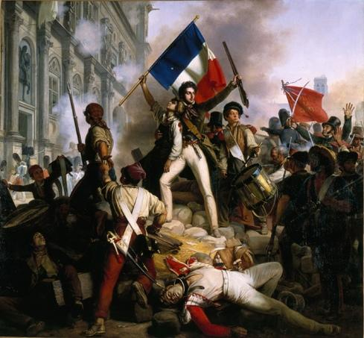
  - Think about what a member of the 3rd Estate would protest against…Some examples are listed below
    - Taxes
    - Food
    - Overspending by government
    - Monarchial abuses
    - 1st & 2nd Estates Special Privileges
  - You will need to have a catchy phrase or saying on your poster
    - For Example: (cannot use these)
      - We are starving When you are partying
      - Don’t be weak Let us speak
      - 1st & 2nd Estate will meet their Fate
      - We pay taxes For your Houses
  - You will need to have a hand drawn picture or symbol on your poster as a visual to aide your catchy phrase or saying
  - The protest sign must be colorful and creative

- Catchy phrase or saying on poster ______/10 Points
- Hand drawn picture or symbol on poster ______/10 Points
- Colorful and Creative ______/10 Points

- Total ______/30 Points
